**JAVASCRIPT OBJECTS**

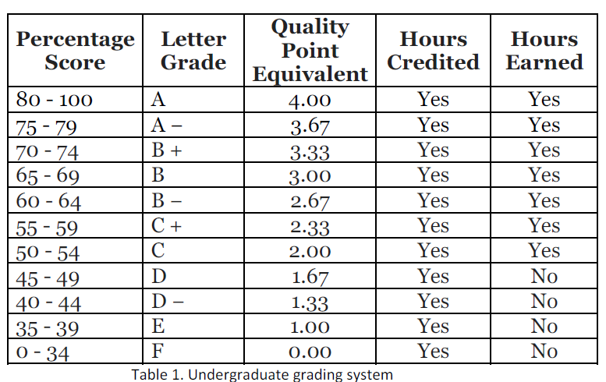

Table 1 above shows the undergraduate grading system effective Semester 1, 2016/2017. At the of the semester, these are the marks obtained by 3 students in the Web Technologies class.

Name Exercises / 20 Lab Test / 20 Project / 60

1 Sarah 18 12 50

2 James 15 16 35

3 Sheila 17 5 15

1. Create a JavaScript object named **Grade** using the **constructor notation**.
2. Create instances of **Grade** by passing the data of the above students.
3. Create properties for **Grade** to capture the **name**, and the marks for **exercises**, **lab test** and **project**.
4. Create a method for **Grade** that display the name of the students, the total marks and the letter grade for each students.